

Technical Documentation

Svm Dr - Recover From Dr

nov 2018

*Number of pages : 6*

*Version : 1.0.1*

# Document Information

## Revision History

|  |  |  |  |  |
| --- | --- | --- | --- | --- |
| Date | Version | Status | Prepared by | Comments |
| 2018/11/14 | 1.0.1 | Draft | WFA | Initial Draft |
|  |  |  |  |  |
|  |  |  |  |  |
|  |  |  |  |  |

## Document Control

|  |  |  |  |
| --- | --- | --- | --- |
| Role | Name | E-mail | Telephone |
|  |  |  |  |
|  |  |  |  |
|  |  |  |  |

## Approval

|  |  |  |  |
| --- | --- | --- | --- |
| Role | Name | Signature | Sign-off Date |
|  |  |  |  |
|  |  |  |  |
|  |  |  |  |
|  |  |  |  |

## Table of Contents

Svm Dr - Recover From Dr 1

nov 2018 1

*Number of pages : 6* 1

*Version : 1.0.1* 1

Document Information 2

Revision History 2

Document Control 2

Approval 2

Table of Contents 3

1 Introduction 4

1.1 Purpose 4

1.2 Description 4

1.3 Assumptions 4

2 Workflow Inputs and outputs 4

2.1 Screenshot 4

2.2 Workflow inputs 5

2.3 Workflow outputs 5

3 Workflow operation 6

3.1 Workflow commands 6

4 Apendix 6

4.1 Workflow versions 6

# Introduction

## Purpose

This document defines the operation of the workflow, input parameters and performed tasks.

## Description

Re-activates the Svm Dr relation  
This will break a reverse snapmirror, clean those mirrors, start the original vserver and stop the dr vserver.  
Then it will recreate the snapmirrors in the original direction.   
After this workflow, the svm dr relation is again as it was (source -> destination)

## Assumptions

For individuals reading this document please note that the following has been assumed:

* A familiarity with NetApp products and technologies
* WFA configuration and NAS system configuration meets requisites and configuration defined in the documents "Storage Engineering WFA Standards" and "Storage Engineering WFA NAS Provisioning and amendments Standards"

# Workflow Inputs and outputs

## Screenshot

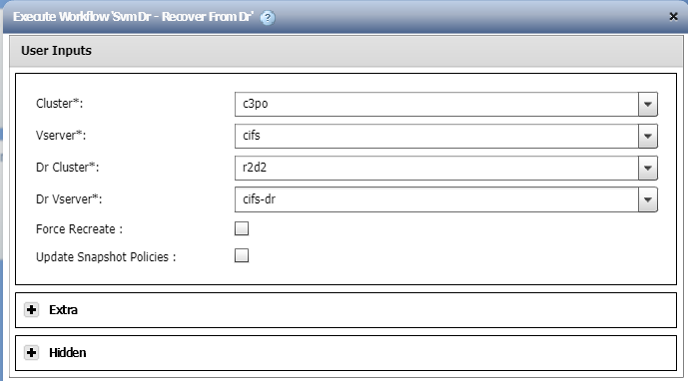

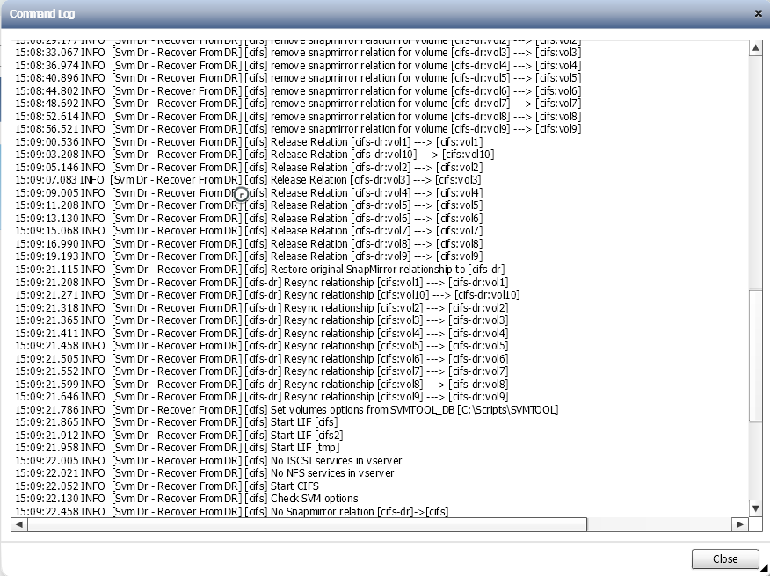

## Workflow inputs

The table below shows the general workflow inputs.

|  |  |  |  |
| --- | --- | --- | --- |
| Name | Type | Description | Notes |
| Cluster | Query |  | Mandatory. |
| Vserver | Query |  | Mandatory. |
| Dr Cluster | Query |  | Mandatory. |
| Dr Vserver | Query |  | Mandatory. |
| Force Recreate | Boolean |  |  |
| Update Snapshot Policies | Boolean |  |  |
| Debug | Boolean |  |  |
| Dr Suffix | Query |  | Mandatory. |

## Workflow outputs

None.

# Workflow operation

## Workflow commands

The table below shows the commands used in the workflow.

Not all the commands may run in every execution. There are conditionals that may disable a set of commands if conditions are met.

|  |  |  |
| --- | --- | --- |
| Name | Base command | Description |
| Search or define | Search or define / 1.0.0 | This is an empty command used for search or define step in the designer. |
| Svm Dr - Recover From DR | Svm Dr - Recover From DR / 1.0.0 | Re-establishes the orginal Svm Dr Relation (ReActive) It will break all reverse snapmirror relations It will bring the source vserver back online (and the lifs) It will bring the destination (dr) vserver offline (unless ForceActivate is used) It will start a resync of the snapmirrors (source -> destination) |

# Apendix

## Workflow versions

|  |  |
| --- | --- |
| Version | Comments |
| 1.0.0 | Initial version |
| 1.0.1 | Remove config file |